**Final Report**

1. **Smart Parking - Using A Crowd Of Taxis To Sense On-Street Parking Space Availability[1]**

The main conclusion of this paper is a strong indication that crowd-sensing of parking

availability, by means of probe vehicles, might be a significant alternative to the expensive

deployment of static parking sensors.

From the experiments done in San Francisco, it is found that a fleet of high mileage probe

vehicles represent a more viable and by far cheaper solution for smart parking.

**Why not implement this one?**

This paper is not using the cell phone to detect the parking spaces rather it is deploying some devices on the vehicle itself.

**Advantages**

1 it is cheaper to deploy.

2 we can get also those parking spaces that a static sensor is not able to detect.

3 it leads to also decrease in accidents when finding a place to park the car.

**Disadvantages**

1 the data that we are getting is dependent on the number of taxis are involved and the path or

trajectories they follow.

2 the areas for parking that we are finding from this data are also by adding some errors where

the data is missing for static sensors but it’s not always true that the place has parking space.

3 the timings for the parking data we are finding here may be found wrong, in this experiment

we are finding that this time the cars are parked/ this time they are not parked and finding the

frequency of parking spaces but not finding the real-time data that the car is parked or not.

**An Overview Of The Model Used In This Paper**

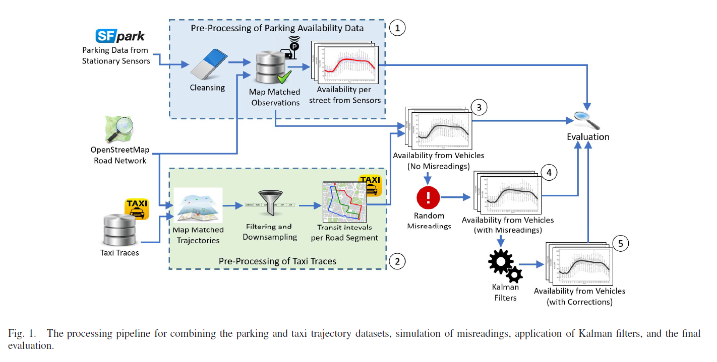

1. **ParkMaster: An in-vehicle, edge-based video analytics**

**service for detecting open parking spaces in urban**

**environments[2]**

Parkmaster estimates parking space availability using video gleaned from drivers’ dash-mounted smartphones on the network’s edge, uploading analytics about the street to the cloud in real-time as participants drive.

Novel-lightweight parked-car localization algorithms enable the system to estimate each parked car’s approximate location by fusing information from the phone’s camera, GPS, and inertial sensors, tracking and counting parked cars as they move through the driving car’s camera frame of view.

Parkmaster is an edge-based sensor system that is feasible with nowadays hardware.

Parkmaster uses the cameras on drivers’ phones to sample the presence of cars at road-side parking spots from the driver’s vehicle itself.

ParkMaster app, which runs on the in-car edge — the driver’s smartphone — performs real-time visual analytics. ParkMaster cloud service maintains a real-time database summarizing the number of available parking spaces on each road and provides client support for location services.

Parkmaster’s cloud services rely on the additional information feed: the number of parking slots per road.

Two major things ParkMaster does recognizes and localizes.

An important thing used by ParkMaster is edge processing which is quite helpful in many aspects.

ParkMaster is not user-dependent as it collects data about the surrounding parked cars not about the users’ actions.

ParkMaster uses Viola-Jones feature-based cascade classifiers to detect complex objects such as cars.

For localizing the parked cars the orientation of the mobile matters.

ParkMaster aims to detect only vehicles parked on the right side of the road.

**Why not implement this one?**

1. It is a very complicated and accurate model that we don’t want in a developing country like India.
2. The model base has been developed for the roads of developed countries that the basic requirements by the model are not satisfied in developing countries like India.

**Advantages:**

1) There is no extra cost for detecting the parking spaces, the one only needs a smartphone with a good camera i.e it is cost-effective.

2) It is able to detect the real-time parking spaces on-street and it doesn’t even need any user input so it can’t be spammed and can’t be corrupted by any user.

3) It has no effect on those users who are not using this app.

**Disadvantages:**

1) The app is able to detect the parking spaces when the car is traveling in the leftmost lane otherwise the app is not able to detect the parking spaces on the street.

2) The parking spaces that are detected must be present in the database of that city.

3) They have not defined the stretch of the legal parking spaces.

4) The app is only tested for developed countries.

**Some images of this paper**

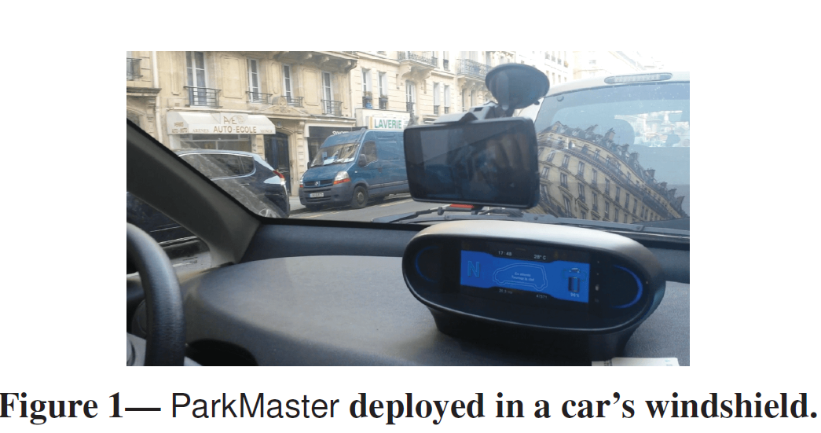

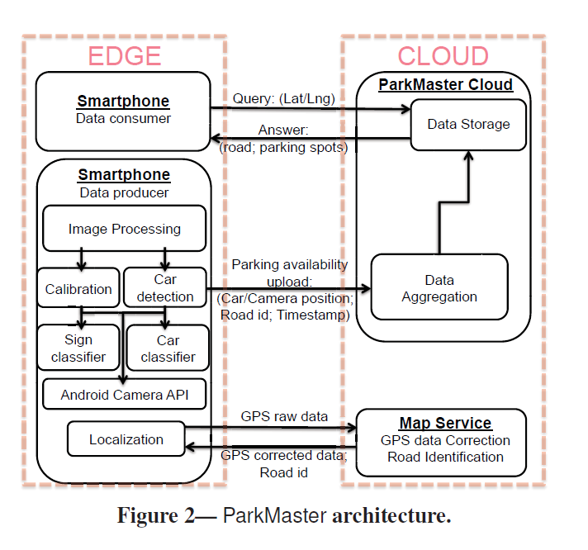

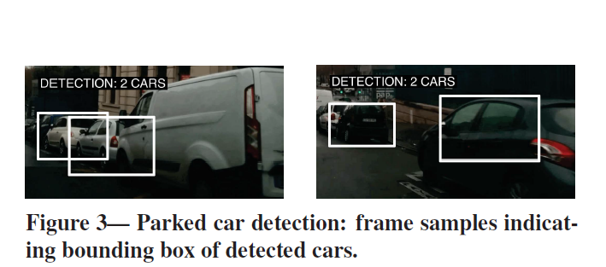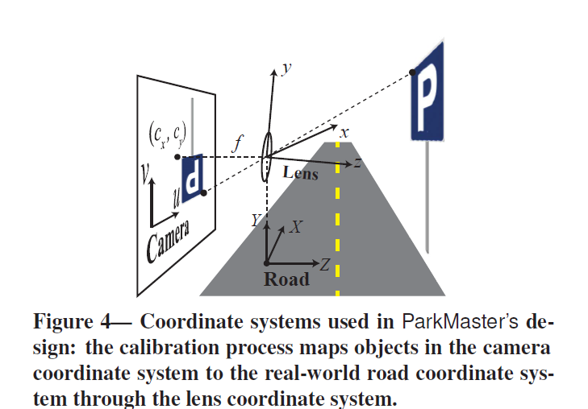

1. **City Scale Monitoring Of On-Street Parking Violations With**

**StreetHAWK[3]**

This paper aims to find unauthorized parked vehicles.

Key Values Taken Into Consideration For this project-

1) LightWeight

2) Low-Cost

3) Privacy-Preserving

4) Real-time

5) Scalable

The lightweight StreetHAWK (an edge-base monitoring system for detecting parking violation in developing nations ) app, running on the mobile phone, captures video with the embedded camera module; locally processes the feed in real-time to identify no-parking zones;

and then matches it with parking policies to detect defaulting vehicles that are illegally parked.

This status report is then sent to the StreetHAWK cloud, which stores the parking violation information and can further notify various city agencies. The non-transfer of captured video to the cloud preserves the privacy of citizens encountered in the street view.

The focus of this project on the two most frequently occurring violations of parking in the vicinity of key facilities( such as schools and hospitals) and no-parking signboards.

**Why Not Implemented This One?**

1. First, we are not doing this thing in our project.
2. Second, the idea can be used for detecting the parking spaces but it has some limitations which make this model inappropriate for developing countries.

**Some relevant images of this paper**

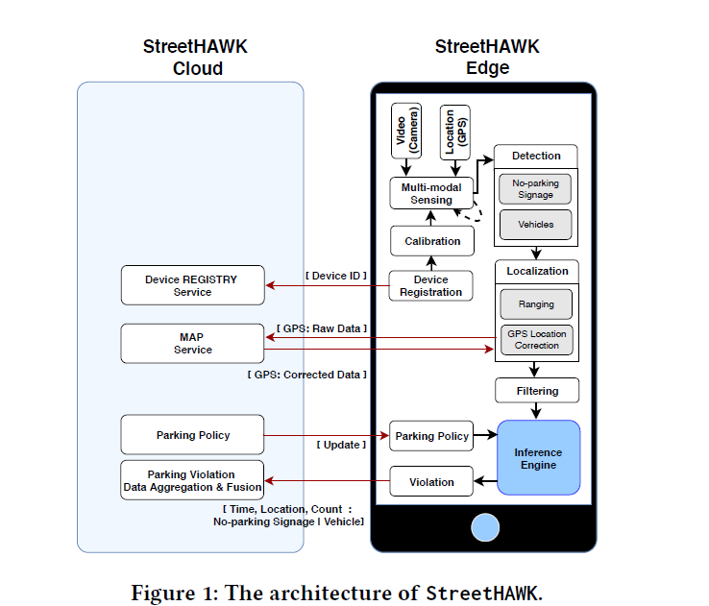

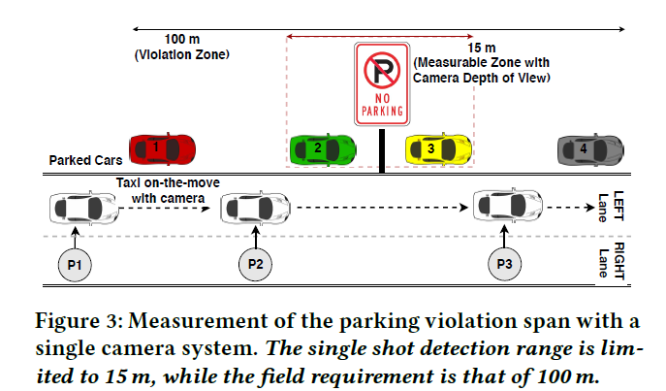

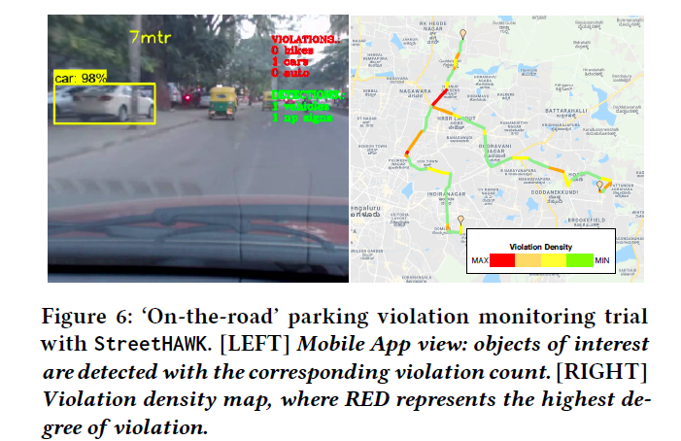

**After reading these three papers we also devoted some time to find the long-termed parks[5] also.**

**After this we have reached one conclusion for finding that is just to detect the space on the streets and that space is feasible for parking or not.**

**To find the space between two cars first I have used some image processing and computer vision techniques which gives results as follows.**

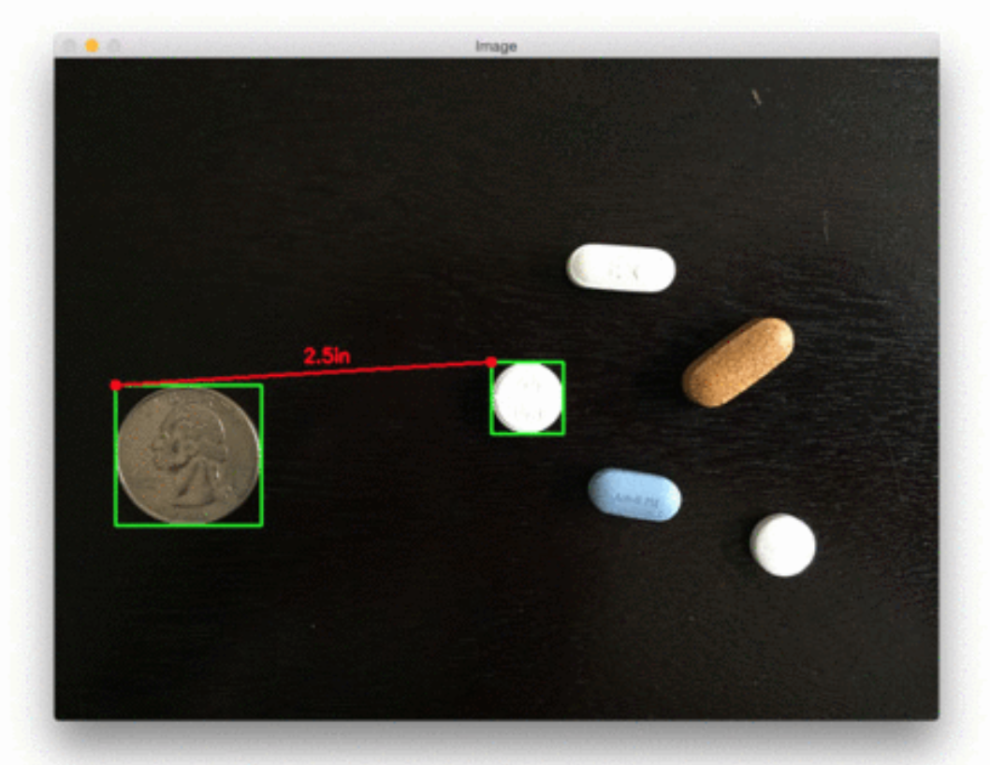

**But this has a problem with finding the actual size of the references.**

**Now I got a paper that has done the same thing but in a different way that is the use of deep learning.**

**4) Convolutional Neural Networks for On-Street Parking Space Detection in Urban Networks[4]**

**What are they doing?**

They have collected the images from the different parts of the city and

trained their model on those images. But the images consist of only parked

cars. Their model is of CNN they have trained their model from scratch on

the training dataset and predicting the accuracy on the test point which is

90%. They have considered the corner cases for detecting the parking

spaces like obstacles besides the car.

**Their Assumption-**

1) The length of the typical car is around 4.5m so they need 5m of

space to park on the street.

2) The distance of the moving car from the curb on which the camera is installed is 3.5m.

3) The angle of the camera with a horizontal is around 75 degrees.

4) The height of the camera from the ground is 90cm.

They are running their model on the laptop with some requirements. The model took at most 2hrs for training but once we got the trained model it

will take very little time to predict the test point.

They also have divided their dataset into two categories easy and hard

images.

Easy for normal cases and hard for corner cases.

**Advantages**

1) We don’t need any calculation for finding the parking spaces.

2) This method can be coordinated with some platforms to detect the

parking spaces in real-time.

3) We can also add prior information in our model like the location of

the school, colleges, hospitals, private or public property to find the

parking spaces in real sense.

4) The model is very light with only two layers but although it is giving

very high accuracy.

5) The model does not require large image datasets to train as it is

trained on only 8300 images and giving high accuracy.

6) It has reduced the complexity of finding parking spaces.

**Disadvantages**

1) The image frame we are processing is dependent on the speed of the

car so if the speed of the car is slow(in case of red lights) then we got

the same image frame and the model will think there are many

parking spaces and it can lead error in the model

**Some relevant images of this paper**

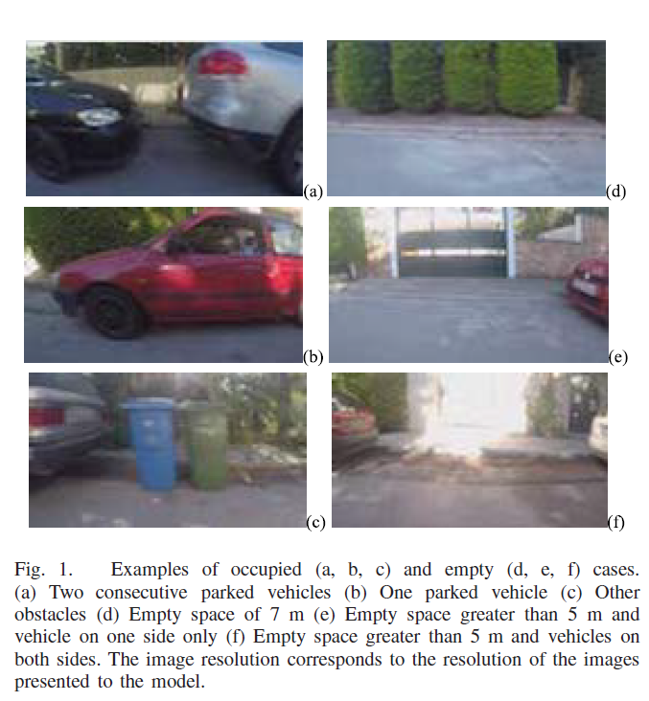

**Now Summary Of My Own Implemented Model**

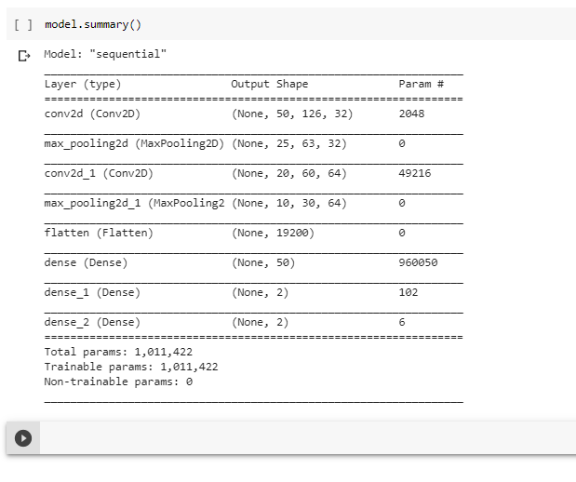

**Accuracy Of My Own Model**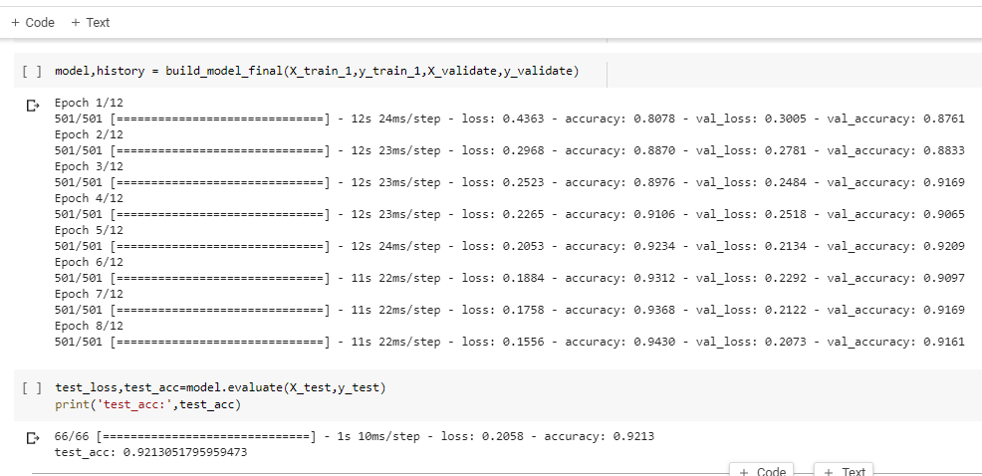

**After that, I have converted this model in the TensorFlow lite format to classify the images on the android app.**

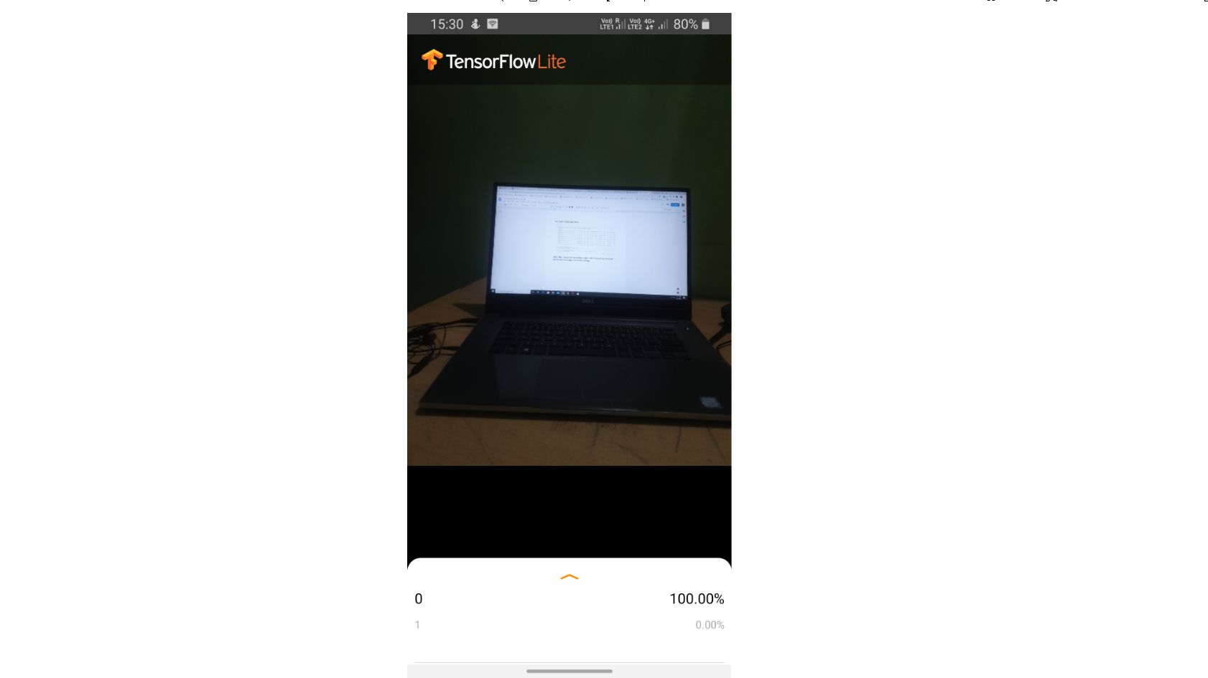

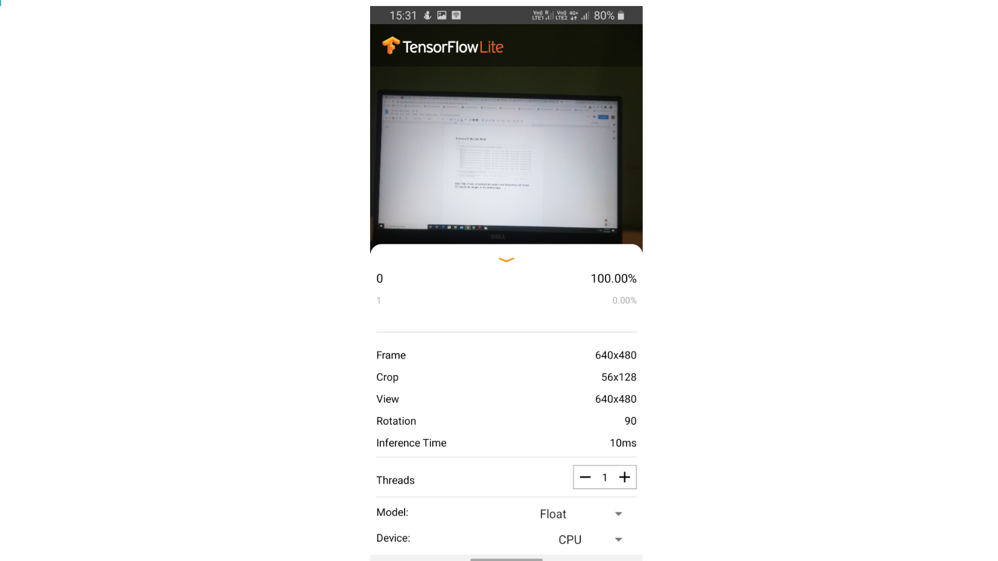

**Pictures Of Live Demo Of App**

It is showing you can park the car here.

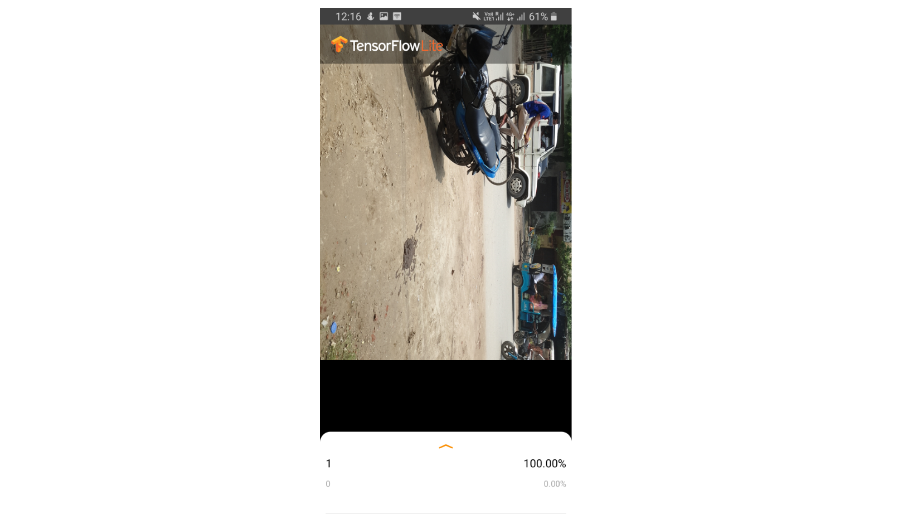

It is showing you can’t park the car here.

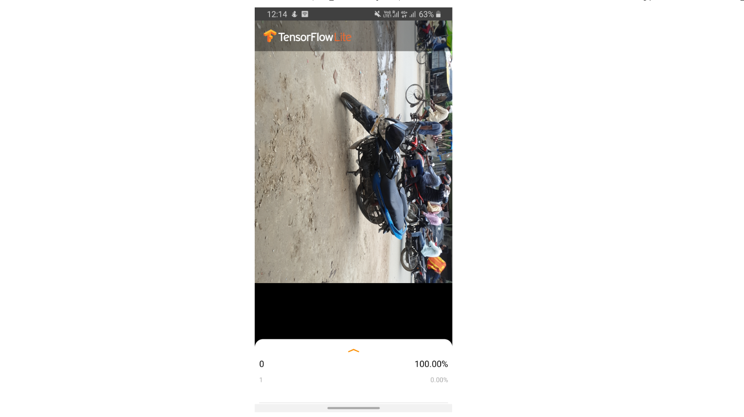

**Before predicting the class of the image I have devised an algorithm to discard the non-useful images or the images that can give bad predictions.**

**Algorithms**

First, find the speed at which the vehicle is moving, to do this I will use the following paper.

**Estimating True Speed of Moving Vehicle using Smartphone-based GPS Measurement**

After finding the speed of the car I can easily find that in what time interval, a car can travel a distance of 5m.

And in this time interval, I will discard all the images that are captured by the phone.

**For future things**

I have to make the app more compatible and user friendly. And in the app, I have to add the above algorithm and also some prior location of schools and hospitals.

**References**

1. F. Bock, S. Di Martino and A. Origlia, "Smart Parking: Using a Crowd of Taxis to Sense On-Street Parking Space Availability," in IEEE Transactions on Intelligent Transportation Systems, vol. 21, no. 2, pp. 496-508, Feb. 2020, doi: 10.1109/TITS.2019.2899149.
2. Giulio Grassi, Kyle Jamieson, Paramvir Bahl, and Giovanni Pau. 2017. Parkmaster: an in-vehicle, edge-based video analytics service for detecting open parking spaces in urban environments. In Proceedings of the Second ACM/IEEE Symposium on Edge Computing (SEC ’17). Association for Computing Machinery, New York, NY, USA, Article 16, 1–14. DOI:https://doi.org/10.1145/3132211.3134452
3. Alok Ranjan, Prasant Misra, Arunchandar Vasan, Sunil Krishnakumar, and Anand Sivasubramaniam. 2019. City Scale Monitoring of On-Street Parking Violations with StreetHAWK. In Proceedings of the 6th ACM International Conference on Systems for Energy-Efficient Buildings, Cities, and Transportation (BuildSys ’19). Association for Computing Machinery, New York, NY, USA, 31–40. DOI:https://doi.org/10.1145/3360322.3360841
4. K. Gkolias and E. I. Vlahogianni, "Convolutional Neural Networks for On-Street Parking Space Detection in Urban Networks," in IEEE Transactions on Intelligent Transportation Systems, vol. 20, no. 12, pp. 4318-4327, Dec. 2019, doi: 10.1109/TITS.2018.2882439.
5. V. Carletti, P. Foggia, A. Greco, A. Saggese and M. Vento, "Automatic detection of long term parked cars," 2015 12th IEEE International Conference on Advanced Video and Signal Based Surveillance (AVSS), Karlsruhe, 2015, pp. 1-6, doi: 10.1109/AVSS.2015.7301722.